Water Jug Problem (AI)
Aim
To solve the Water Jug Problem using Artificial Intelligence techniques and obtain the required quantity of water.

Objectives
- To understand state-space representation.
- To apply problem-solving techniques in AI.
- To achieve the target amount of water.
- To understand the concept of search algorithms.

Algorithm
- Start.
- Fill Jug B (3 liters).
- Pour water from Jug B into Jug A.
- Refill Jug B.
- Pour water into Jug A until Jug A is full.
- Empty Jug A.
- Transfer the remaining water from Jug B to Jug A.
- Check if Jug A contains 2 liters.
- If yes, display the result.
- Stop.

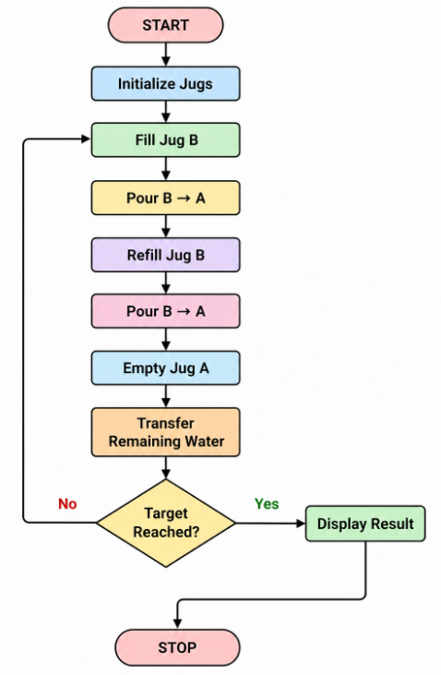
SOURCE CODE
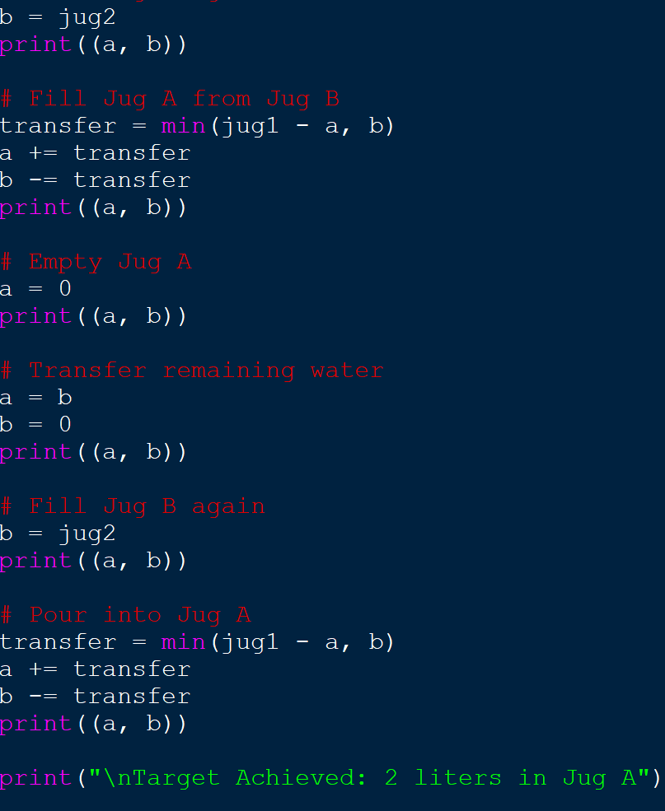

OUTPUT
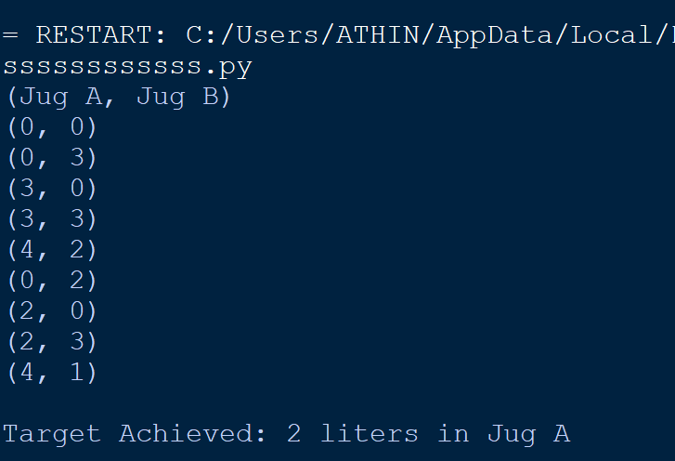

Result
The Water Jug Problem was successfully solved, and the required quantity of water (2 liters) was obtained using the sequence of valid operations.

